IPv6 Subnetting Practice
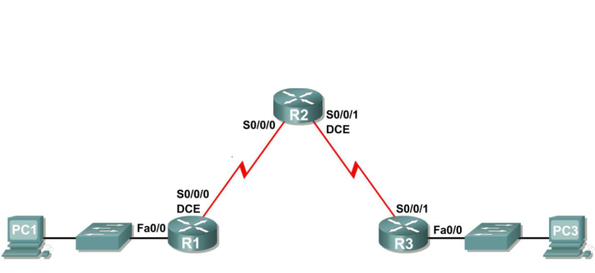

Original IPv6 Network: 2001:DB8:1234::/48

- You have been given the above topology diagram and network address information. You have been asked to subnet the address space to create the required number of IPv6 networks.
Answer the following questions:

How many subnets do you need? ________

What is the prefix length for each of the new IPv6 subnets? ________

- Fill in the below table.
Assign an IPv6 network and address to each interface.
Assign an IPv6 link-local address to each interface. Ensure each link-local address is the same for each router.

Interface | Network Address | IPv6 Address | Link Local Address
R1 Fa0/0
R1 S0/0/0
R2 S0/0/0
R2 S0/0/1
R3 S0/0/1
R3 fa0/0
- Is it common practice to have Link-local addresses be the same or different for each interface on a router?

